**Workpaper A.1.A – Ensure That Current Storage Requirement Supports Current System Needs.**

Source: AuditBoard.

Provided by: Padmalatha Ajit (Senior Manager, Application Development)

Date: 5/20/2021

Description: The attached screenshot below shows a system generated data sizing strategy for SimpleDose from current year of implementation 2021 through 2024 with emphasis on a predicted 5% year on year growth for storage capacity (List 1). The application Team also noted during walkthrough meeting that the system currently has data storage to support system needs for the next 2 to 3 years.

IA Notes: The attached screenshots below show that there is a data sizing strategy in place to support SimpleDose yearly growth based on generated pre-existing transactional file size estimation. Additionally, based on the information gathered from walkthrough meeting with Application team, IA noted that current storage requirement supports current system needs

Attribute A

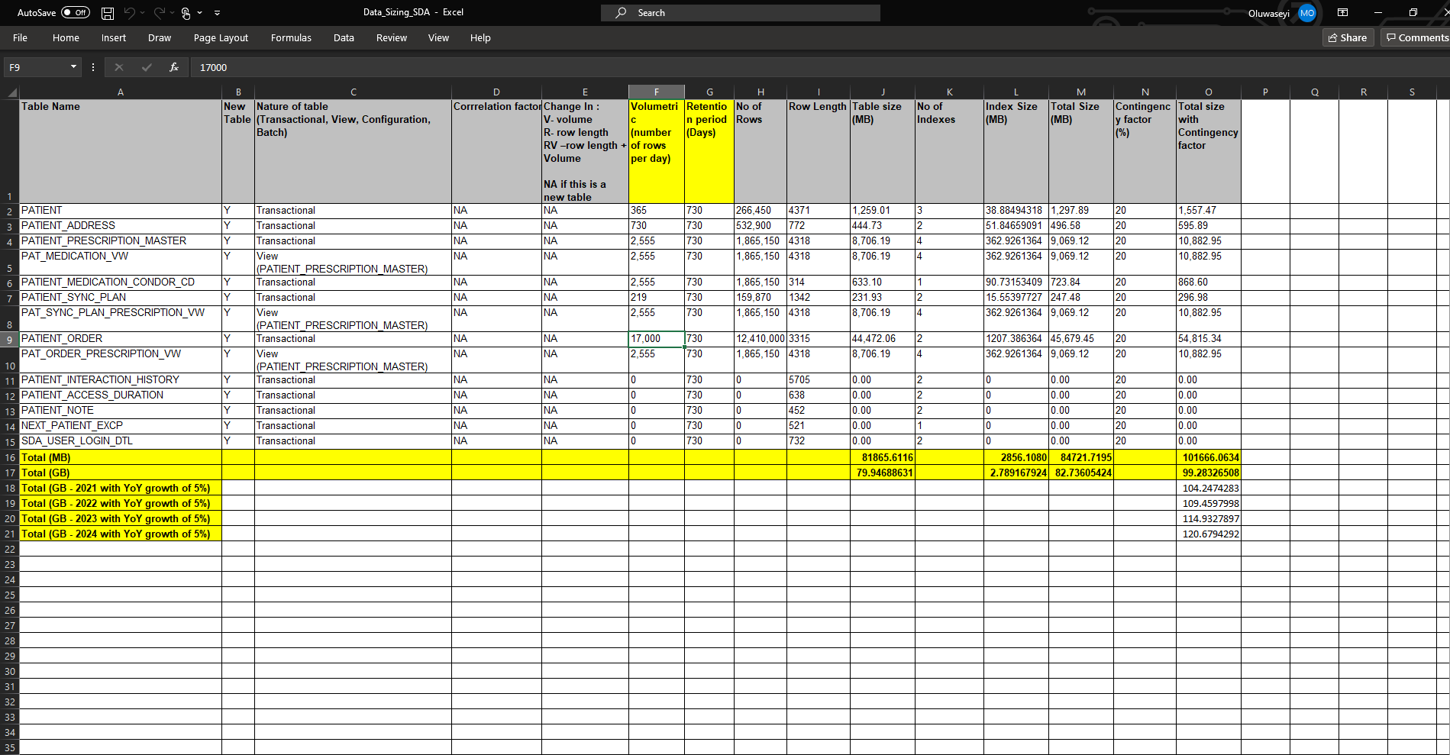

List 1: Screenshot showing data storage sizing strategy from SimpleDose till year 2024.

IA reviewed the entire rows and columns within the data sizing log. IA observed that each category of data imputation for SimpleDose is subcategorized into separate “Table Names” as seen in Row A1 in List 1 above. The total file size for each subcategory of data (Table Name) is highlighted in Row O and likewise a year to year growth for SimpleDose per 5% growth yield is estimated to reveal how much space will potentially be need by SimpleDose from 2021 through 2024. In Addition, During the walkthrough meetings with the application development team, Padmalatha Ajit, Senior Manager, Application Development, noted that the system currently has enough data storage to last the next 2 to 3 years ([Capacity Planning Narrative](https://cvshealth.auditboardapp.com/workpaper?workpaper_id=53028&name=Capacity%20Planning%20Narrative))

A.1